Risk Mapping Analysis
The heat map shows a clear concentration of the most serious risks in the upper-right portion of the chart, where both likelihood and impact are high. These risks include:
- Risk 5 (81)
- Risk 6 (54)
- Risk 12 (63)
- Risk 15 (72)
- Risk 27 (81)
- Risk 28 (45)
- Risk 30 (42)
These risks are classified as high risk because they combine either very high probability, very high impact, or both. They represent the areas where management attention, mitigation planning and continuous monitoring are most needed.
The moderate-risk zone contains risks such as Risk 2, Risk 3, Risk 11, Risk 19, Risk 20, Risk 25, Risk 26 and Risk 29. These do not represent immediate crisis-level threats, but they are important because they can escalate if not controlled.
The low-risk zone includes the remaining risks, which are either low-likelihood, low-impact, or both. Although these risks are not immediate priorities, they should still be monitored because changes in the business environment or competitive landscape could increase their significance over time.
Overall, the risk mapping demonstrates that Manulife’s most serious exposures are concentrated around strategic competition, enterprise disruption, regulatory failure and technology-related vulnerabilities. This makes the heat map a useful tool for risk prioritization and communication.

Python Heat Map Explanation
The Python code grouped risks by their likelihood and impact coordinates and then plotted them into colored cells using predefined thresholds. This programmatic approach adds value because it:
- reduces manual plotting errors,
- ensures consistency with the risk calculation sheet,
- allows quick updates if scores change,
- and provides a repeatable method for future risk reviews.
The code also displays the risk name and total score inside each cell, making it easy to compare the numeric values with the visual classification.

Conclusion
This risk assessment used a structured method to evaluate and prioritize Manulife’s key risks. By calculating scores from likelihood and impact, updating the risk register and mapping the risks in a heat map, the analysis provides a clear view of where the organization faces the greatest exposure. The most critical risks fall within the high-risk zone and are mainly associated with strategic competition, major operational or technology failures and regulatory exposure.
The use of both Excel and Python strengthens the analysis by combining manual interpretation with programmatic consistency. This approach supports better decision-making and provides management with a clear basis for identifying, prioritizing and responding to risk.
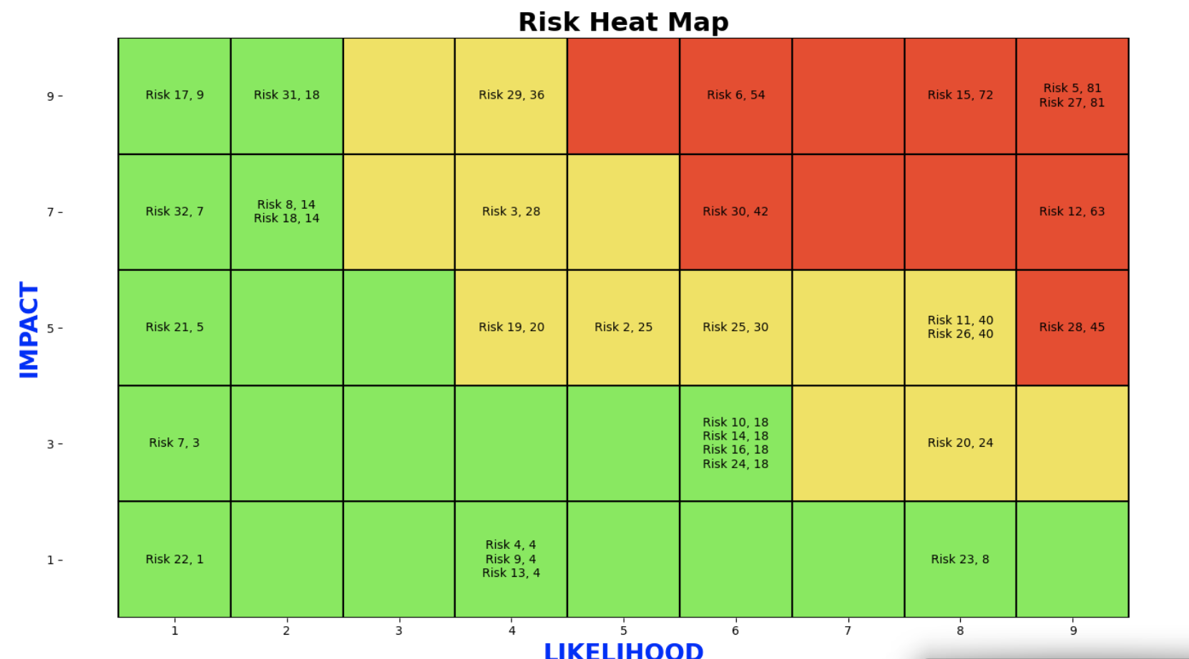
References
Deloitte. (2023). 2023 global insurance outlook: Navigating disruption and transformation in insurance. Deloitte Insights. https://www2.deloitte.com
International Organization for Standardization. (2018). ISO 31000: Risk management—Guidelines. ISO. https://www.iso.org/iso-31000-risk-management.html
IBM Security. (2023). Cost of a data breach report 2023. IBM Corporation. https://www.ibm.com/security/data-breach
Investopedia. (2024). Risk management in business and finance. https://www.investopedia.com
World Economic Forum. (2023). Global risks report 2023. https://www.weforum.org/reports/global-risks-report-2023

